**Homework_3 Group Assignment**

**BUAN 6337.003 – Predictive Analytics Using SAS**

**GROUP - 6:**

**Bharath Venkatesh Srinivasan (bxs210006)**

**Harikrrishnan Boopathi (hxb210007)**

**Nishanth Naga Anand (nxn200004)**

**Sai Likitha Gavirneni (sxg190122)**

**Naga Madhulatha Ramabhotla (nxr200043)**

Among those nine explanatory variables, only 5 variables are significant namely, edu (education), hr (work hours per year), selfempl (selfemployed), salaried and age. The t-values for all the variables can be inferred from the below output.

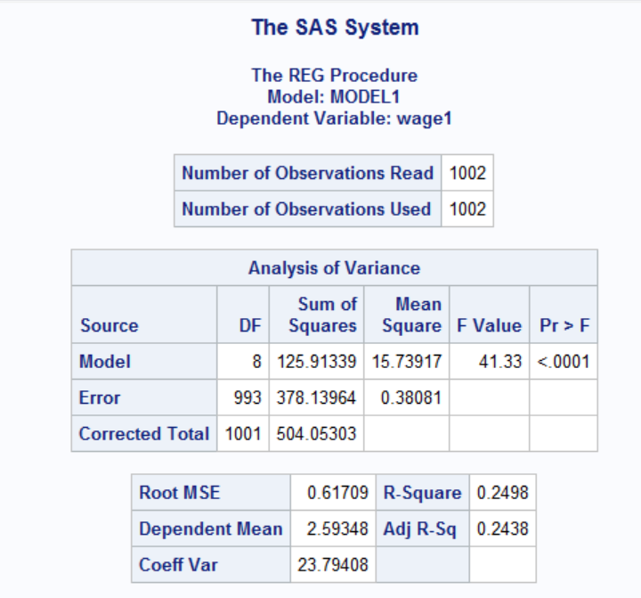

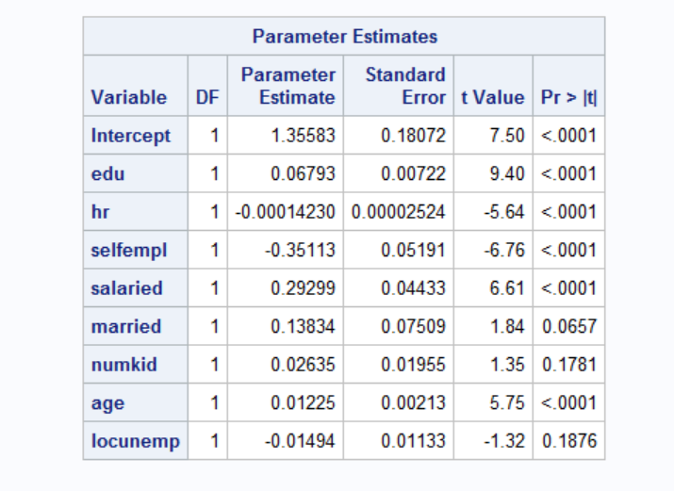

The best regression model is the one with the 5 explanatory variables – edu, hr, selfempl, salaried and age with the highest R-squared (0.2432) and adjust R-squared (0.2394) value.

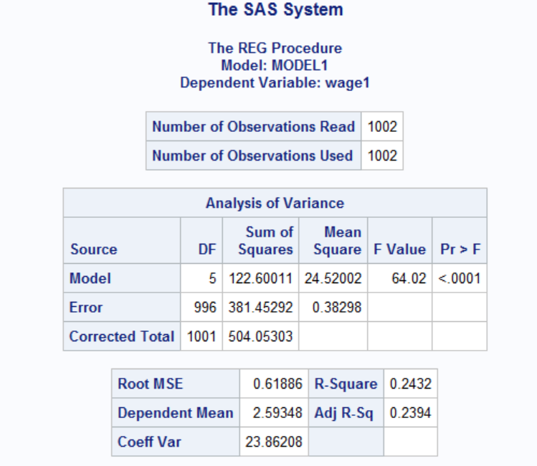

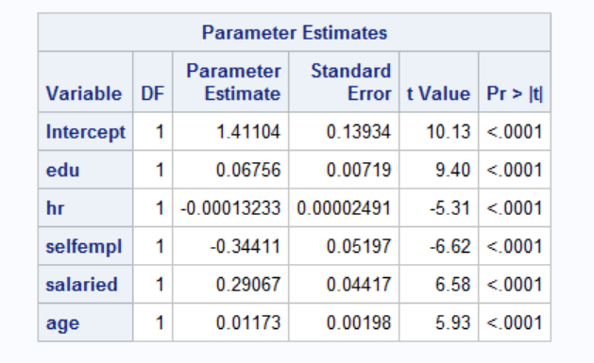

Wage = 1.41104 + 0.06756*edu - 0.00013233*hr - 0.29067*selfempl + 0.29067*salaried + 0.01175*age

Multicollinearity can be inferred by checking the correlation between independent variables. Based on results of VIF and COLLIN, it is inferred that there are no correlation or relationship between the independent variables in the model used to explain the target variable.

VIF diagnosis:

Further interpreting the VIF values, the Variance inflation values for the explanatory variables are less than 10. Hence, it is confirmed that there is no presence of multicollinearity between the eight variables in the model.

COLLIN diagnosis:

Based on the results of COLLIN Results table, the condition indexes are smaller than the threshold value of 100. Thus, it could be inferred that the is no presence of multicollinearity between the variables in the model.

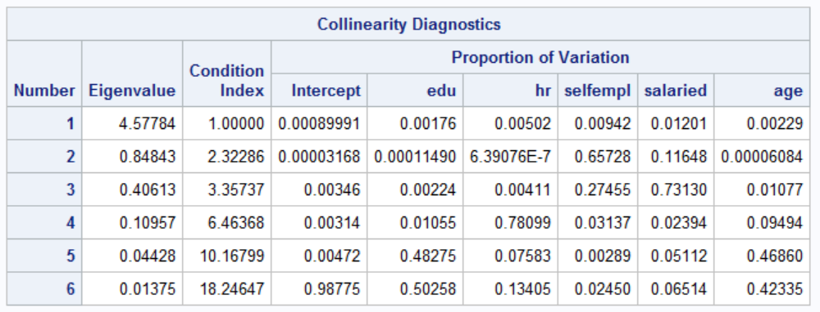

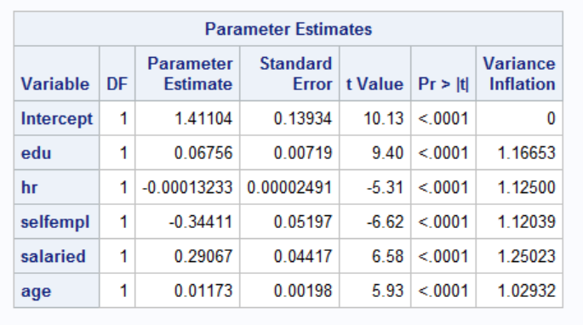



Using the finalised model with the 5 variables, nonlinearity is checked by adding a squared term of continuous explanatory variables in the model and the output is tabulated below,

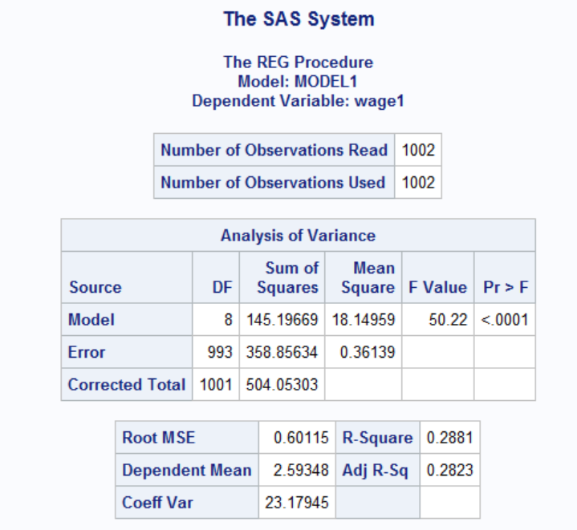

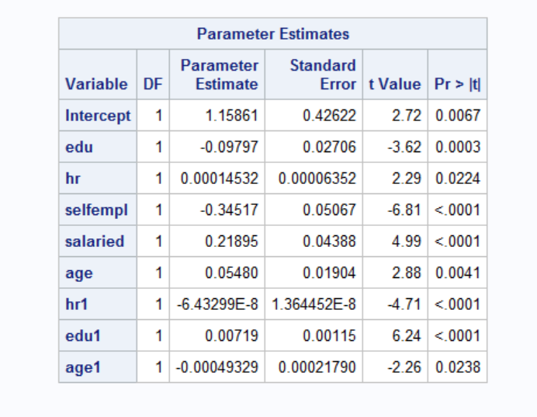

The required results are tabulated below,

|  |  |  |
| --- | --- | --- |
| **Model and its respective squared variable** | **P > 0.05** | **Result** |
| Model 1 – Education (edu) | False, fail to reject null | The relationship between Wage and education is non-linear |
| Model 2 – Work hours (hr) | False, fail to reject null | The relationship between Wage and work hours is non-linear |
| Model 3 – Age (age) | False, fail to reject null | The relationship between Wage and age is non-linear |

Conclusion:

From the results, it is noted that the p-value of edu*edu, age*age and hr*hr is <0.05, so we reject the null hypothesis, signifying that those variables are causing non-linearity. So, we include the squared term of edu, hr and age to add non-linearity to the model.

R-squared inference:

From the below screenshot we could infer that the R-squared & adjusted R-squared for the best fitting model is 0.28 and 0.28 respectively.

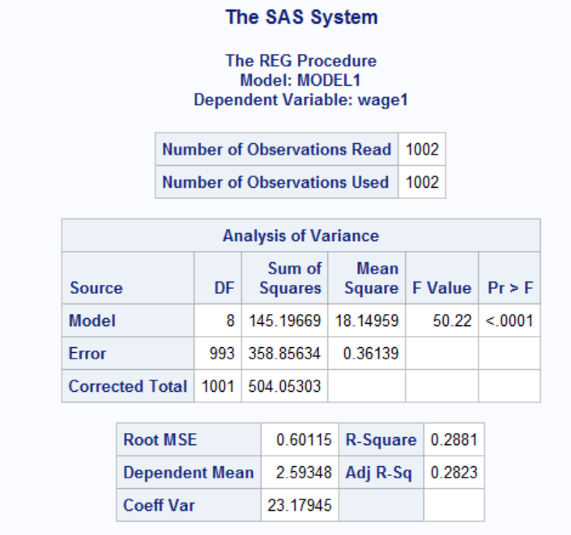

The R-squared and adjusted R-squared values are similar for the model. 28% of the variance or the variability in the target variable - log(wages) is explained by the explanatory variables in the model.

T- value interpretation:

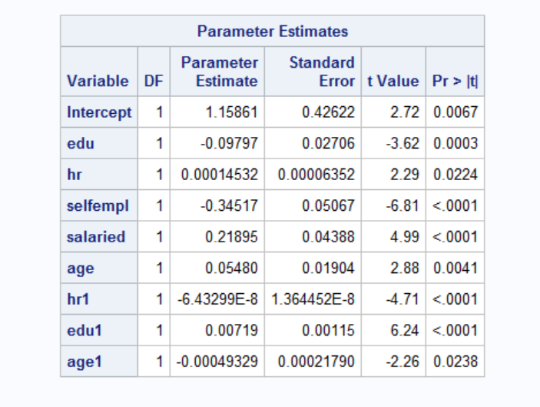

The above screenshot indicates that each of the variables in the model (including the square terms that were added to handle non-linearity) are significant with t-values greater than 1.96 (as per 95% CI).

Variable Coefficients:

1. Edu (Education in years)

Since the coefficient of edu is -0.097 and coefficient of edu*edu (squared term -edu1) = 0.0071 then the shape of the curve first decreases and then increases (U shaped).

Since we have added a square/quadratic term to handle nonlinearity, the percentagechange depends on the education value. So, we could interpret edu’s coefficient as,

If the year of education increases by one year, then the dollar wage hour changes by 100*(-0.097+2*0.0071*edu) %

1. Hr (Work hours)

Since the coefficient of Hr is 0.00014 and coefficient of Hr*Hr (squared term -Hr1)

= -6.43299E-8 then the shape of the curve first increases and then decreases (Inverted U shaped).

Since we have added a square/quadratic term to handle nonlinearity, the percentage change depends on the education value. So, we could interpret Hr’s coefficient as,

If the year of education increases by one year, then the dollar wage hour changes by 100*(0.00014 +2*-6.43299E-8 *Hr) %

1. Selfempl

The dollar wage per hour will be 34.5% more for people who are not self-employed when compared to the self-employed people

1. Salaried

The dollar wage per hour will be 21 % more for people who are salaried when compared to the people who are not salaried.

1. Age

Since the coefficient of age is 0.054 and coefficient of age*age (squared term -age1) = -0.0004 then the shape of the curve first increases and then decreases (Inverted U shaped).

Since we have added a square/quadratic term to handle nonlinearity, the percentage change depends on the education value. So, we could interpret age’s coefficient as,

If the year of education increases by one year, then the dollar wage hour changes by 100*(-0. 054 +2*0. 0004 *age) %

Collinearity diagnosis:

VIF diagnosis:

Further interpreting the VIF values, the Variance inflation values for the explanatory variables are less than 10. Hence, it is confirmed that there is no presence of multicollinearity between the eight variables in the model.

COLLIN diagnosis:

Based on the results of COLLIN Results table, the condition indexes are smaller than the threshold value of 100. Thus, it could be inferred that the is no presence of multicollinearity between the variables in the model.

Since the coefficient of edu is -0.097 and coefficient of edu*edu (squared term -edu1) = 0.0071 then the shape of the curve first decreases and then increases (U shaped).

Since we have added a square/quadratic term to handle nonlinearity, the percentage change depends on the education value. So, we could interpret edu’s coefficient as,

If the year of education increases by one year, then the dollar wage hour changes by

100*(-0.097+2*0.0071*edu) %

Note: Here the % change depends on education value since we are having quadratic term.

Table of Coefficients:

|  |  |  |  |  |  |
| --- | --- | --- | --- | --- | --- |
| **Variables** | **OLS Regression** | **Fixed one** | **Fixed Two** | **Random one** | **Random Two** |
| Intercept | 1.15861 | -0.78993 | 4.97093 | 1.322901 | 1.322944 |
| edu | **-0.09797** | 0 | 0 | **-0.09432** | **-0.09432** |
| hr | **0.00014532** | **-0.00041** | **-0.00041** | **-0.00022** | **-0.00022** |
| selfempl | **-0.34517** | **-0.22899** | **-0.22991** | **-0.27204** | **-0.27205** |
| salaried | **0.21895** | **0.12572** | **0.12723** | **0.18169** | **0.1817** |
| age | **0.0548** | **0.13443** | 0 | **0.068983** | **0.068978** |
| hr1 | **-6.43E-08** | 2.17E-08 | 2.16E-08 | -7.33E-09 | -7.33E-09 |
| edu1 | **0.00719** | 0 | 0 | **0.007299** | **0.007299** |
| age1 | **-0.00049329** | **-0.00141** | **-0.0014** | **-0.00068** | **-0.00068** |

OLS & Fixed One:

|  |  |  |  |
| --- | --- | --- | --- |
| **Variables** | **OLS Regression** | **Fixed one** | **Percentage change** |
| Intercept | 1.15861 | -0.78993 | 168.1791112 |
| edu | -0.09797 | 0 |  |
| hr | 0.00014532 | -0.00041 | 382.1359758 |
| selfempl | -0.34517 | -0.22899 | 33.65877683 |
| salaried | 0.21895 | 0.12572 | 42.57867093 |
| age | 0.0548 | 0.13443 | 145.3083942 |
| hr1 | -6.43E-08 | 2.17E-08 | 133.7012804 |
| edu1 | 0.00719 | 0 |  |
| age1 | -0.00049329 | -0.00141 | 185.835918 |

The coefficients of all the variables have changed in the OLS and Fixed One model and the percentage change between the coefficients are mentioned in the table above.

Hr is the variable with a coefficient that has varied the highest among all variables.

The edu is a time invariant variable and is not estimated as part of the Fixed one model.

OLS & Fixed Two:

|  |  |  |  |
| --- | --- | --- | --- |
| **Variables** | **OLS Regression** | **Fixed Two** | **Percentage change** |
| Intercept | 1.15861 | 4.97093 | 329.0426459 |
| edu | -0.09797 | 0 |  |
| hr | 0.00014532 | -0.00041 | 382.1359758 |
| selfempl | -0.34517 | -0.22991 | 33.3922415 |
| salaried | 0.21895 | 0.12723 | 41.89038593 |
| age | 0.0548 | 0 |  |
| hr1 | -6.43E-08 | 2.16E-08 | 133.5458317 |
| edu1 | 0.00719 | 0 |  |
| age1 | -0.00049329 | -0.0014 | 183.8087129 |

The coefficients of all the variables have changed in the OLS and Fixed Two model and the percentage change between the coefficients are mentioned in the table above.

The hr (Work hours per year) variable’s coefficient has recorded the highest percentage difference/change between the two models.

Time invariant variables Age and Edu are not estimated in the Fixed two model as they will get cancelled out.

OLS & Random One:

|  |  |  |  |
| --- | --- | --- | --- |
| **Variables** | **OLS Regression** | **Random one** | **Percentage change** |
| Intercept | 1.15861 | 1.322901 | 14.1800088 |
| edu | -0.09797 | -0.09432 | 3.725630295 |
| hr | 0.00014532 | -0.00022 | 251.3900358 |
| selfempl | -0.34517 | -0.27204 | 21.18666164 |
| salaried | 0.21895 | 0.18169 | 17.01758392 |
| age | 0.0548 | 0.068983 | 25.88138686 |
| hr1 | -6.43E-08 | -7.33E-09 | 88.60560952 |
| edu1 | 0.00719 | 0.007299 | 1.515994437 |
| age1 | -0.00049329 | -0.00068 | 37.84994628 |

The coefficients of all the variables have between the OLS and Random One model.

Edu (Education in years) has the least change in its coefficient when compared to the rest.

The hr (Work hours per year) variable’s coefficient has varied the most between the two models.

OLS & Random Two:

|  |  |  |  |
| --- | --- | --- | --- |
| **Variables** | **OLS Regression** | **Random Two** | **Percentage change** |
| Intercept | 1.15861 | 1.322944 | 14.18372015 |
| edu | -0.09797 | -0.09432 | 3.725630295 |
| hr | 0.00014532 | -0.00022 | 251.3900358 |
| selfempl | -0.34517 | -0.27205 | 21.18376452 |
| salaried | 0.21895 | 0.1817 | 17.01301667 |
| age | 0.0548 | 0.068978 | 25.87226277 |
| hr1 | -6.43E-08 | -7.33E-09 | 88.60560952 |
| edu1 | 0.00719 | 0.007299 | 1.515994437 |
| age1 | -0.00049329 | -0.00068 | 37.84994628 |

The coefficients of all the variables have changed in the OLS and Random Two model and the percentage change between the coefficients are mentioned in the table above.

The coefficients of all the variables have changed between the OLS and Random Two model and the percentage change between the coefficients are mentioned in the table above.

The change percentage for hr (Work hours per year) is the highest and for edu (Education in years) is the least.

*Non estimable parameters:*

In fixed effects model, the parameters Education in years (Edu) and Age are not estimated as they both are time invariant variables, which does not change over time. Those variables tend to cancel out when subtracted in the fixed intercept estimator.

**Fixed one**

The coefficient of education is 0 in both the cases, this can be because education stays mostly constant over period of time and in fixed effects model it gets eliminated

**Random one**

With 1 year increase in education, wages change by 100*(-0.094+2*0.0073*edu)%

**Fixed two**

The coefficient of education is 0 in both the cases, this can be because education stays mostly constant over period of time and in fixed effects model it gets eliminated

**Random two**

With 1 year increase in education, wages change by 100*(-0.094+2*0.0073*edu)%

"Note: In all the cases, changes can be increase or decrease depending on number of years of education

**Ex:** If years of education is 10, wages will have a positive coefficient but if it is 1 year, it will have a negative coefficient"

When edu = 1, The coefficient is changed by 0.42% across regression model and random effects model. Though the change seems to be small, its better to use random effects model since we observe some difference in comparison to regression model and also as education increases the difference will be more.

Using Random effects model helps us avoid unobserved heterogeneity.

The correct estimate would be with 1 year increase in education, wages increases by 100*(-0.094+2*0.0073*edu)%